Directional Light

📘 Definition
# Source: AI Source: Provided by: [Data Path: Persons Table -> ID Column: 1, Name_En Column: Motasem Essam] -> From: [ChatGPT] on [5/2/2026]
A Directional Light is a type of light source in computer graphics where light comes from a single direction, like sunlight, and all light rays travel parallel to each other.

☀️ How Directional Light works
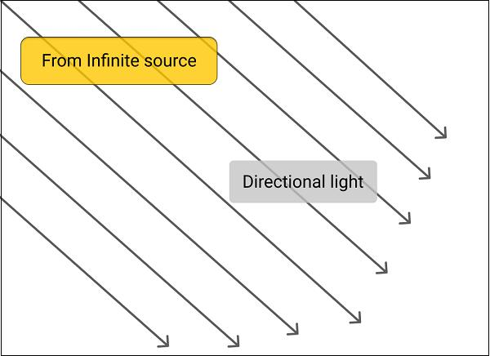
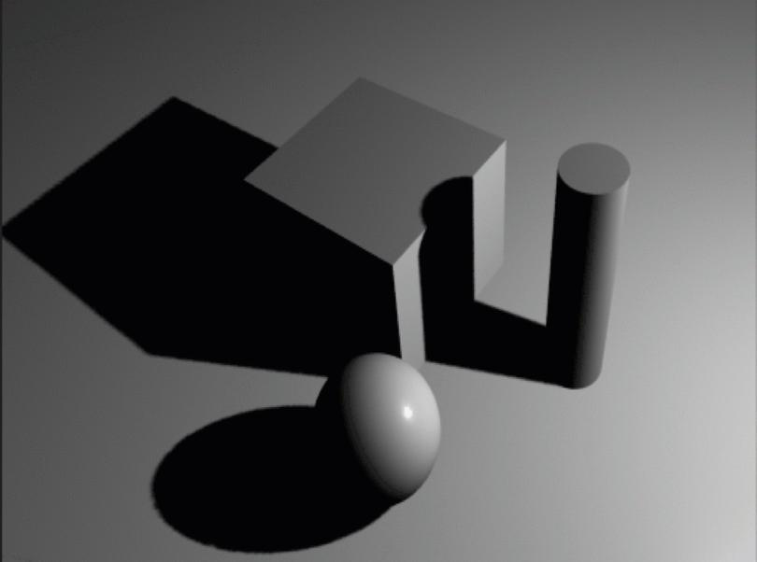
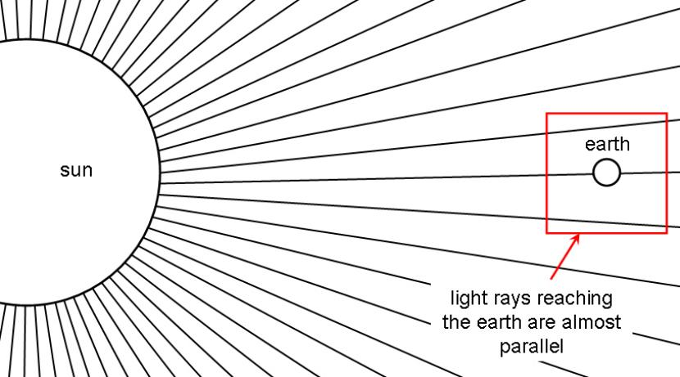
- Light does not come from a specific point
- Instead, it comes from a far away source (like the sun)
- All rays are parallel
- Produces consistent lighting across large areas
- Creates shadows based on object direction

🧠 Simple example
# Source: AI Source: Provided by: [Data Path: Persons Table -> ID Column: 1, Name_En Column: Motasem Essam] -> From: [ChatGPT] on [5/2/2026]
Think of:
- ☀️ Sunlight during daytime
Even though the sun is far away, it lights up everything in the same direction.

🎮 Where Directional Light is used
# Source: AI Source: Provided by: [Data Path: Persons Table -> ID Column: 1, Name_En Column: Motasem Essam] -> From: [ChatGPT] on [5/2/2026]
- Outdoor scenes in video games 🌍
- Daylight in 3D animations 🎬
- Landscape simulations 🏞️
- Architectural visualization 🏢

⚙️ Key features
# Source: AI Source: Provided by: [Data Path: Persons Table -> ID Column: 1, Name_En Column: Motasem Essam] -> From: [ChatGPT] on [5/2/2026]
- ☀️ Has no fixed position, only direction
- ➡️ Light rays are parallel
- 🌑 Creates long, consistent shadows
- 🌍 Lights the entire scene evenly

🚀 In short:
# Source: AI Source: Provided by: [Data Path: Persons Table -> ID Column: 1, Name_En Column: Motasem Essam] -> From: [ChatGPT] on [5/2/2026]
Directional Light = light that comes from one direction like the sun, with parallel rays lighting everything in a scene.

